|  |  |  |
| --- | --- | --- |
| **LAB 321Assignment** | **Type:** | **LongAssignment** |
| **Code:** | **J3.L.P0021** |
| **LOC:** | **800** |
| **Slot(s):** | **15** |

**Title:** Maria and Paul's Wedding

**Background**

### You want to share your wedding party information to all your friend.

Complete this assignment to know how to write a wedding blog.

Reference site:<http://www.simplesite.com/us-123wedding>

**Program Specifications**

Program a web site to introduce your wedding party, detail functions of this website is described below

**Features:**

This website contains 5 main functions

* Function 1 : Home page : ( see PIC 01)
  + Display all entries sorted by published date
  + Each entries contains
    - Entry name
    - Entry Icon
    - Description picture
    - Entry description
* Function 2 : Photo album ( PIC 02)
  + Display all available photo
* Function 3 : Wishes list: ( PIC 03)
  + Display the wishes
* Function 4 : Guest book
  + Help guests to submit their message , their wishes
* Function 5 : party address
  + Display contact and location of party address

You do not need to write interface for admin control panel, you can add data manually (use SQL SERVER Management studio).

Note: All data must be load from database, not hard code in page.

***Expectation of User interface:***

Pic 01 : Home Page

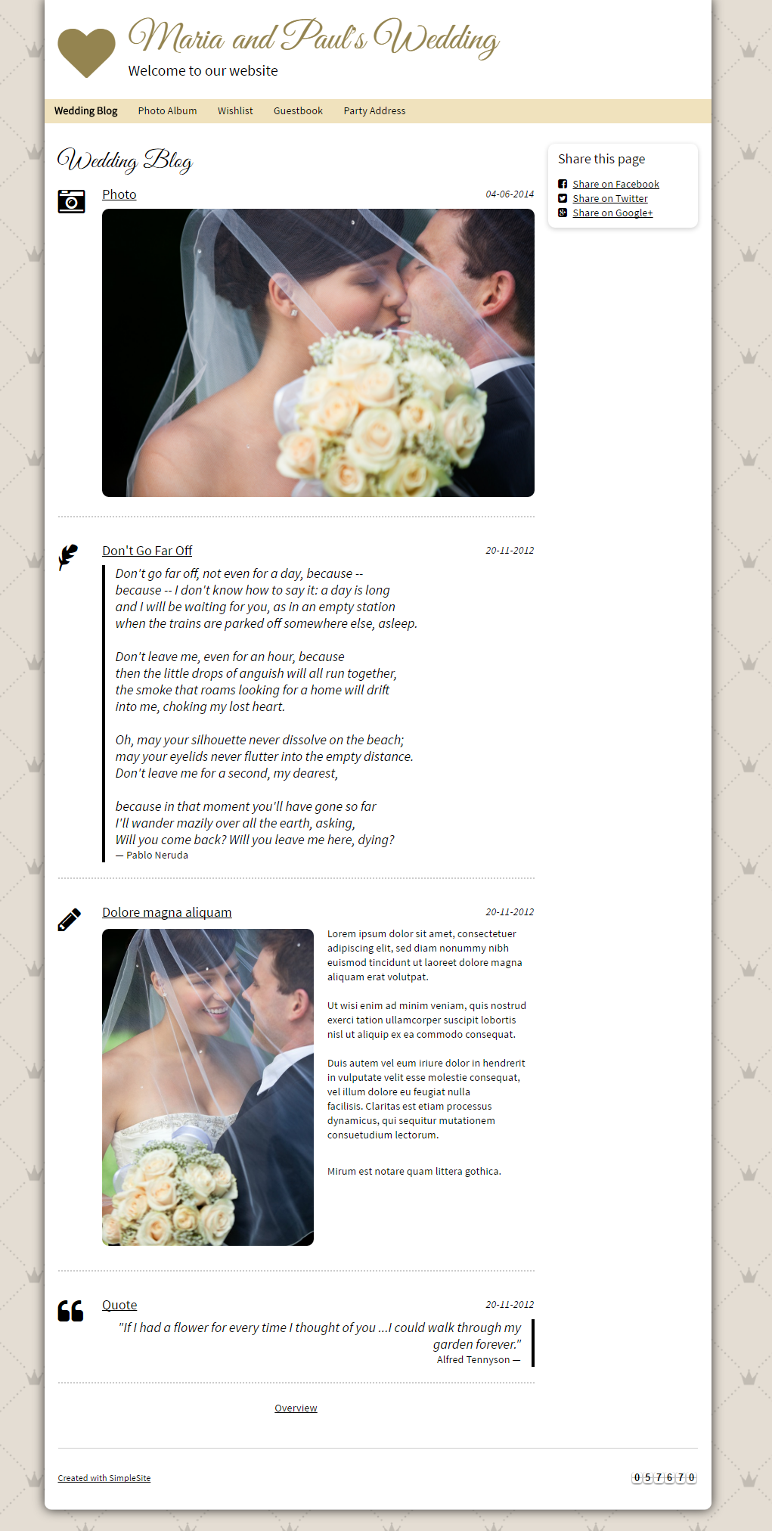

PIC 02 : When click to overview, system display all entries in short titles

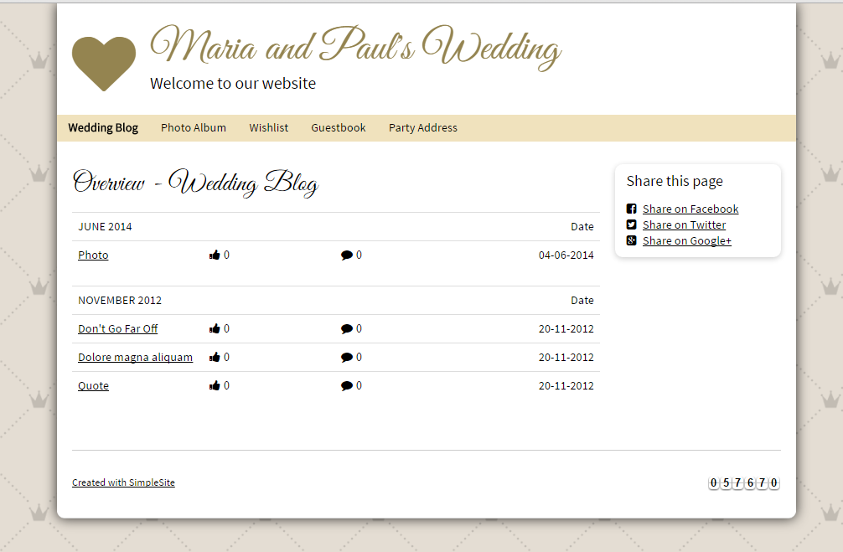

PIC 03 : Display photo album

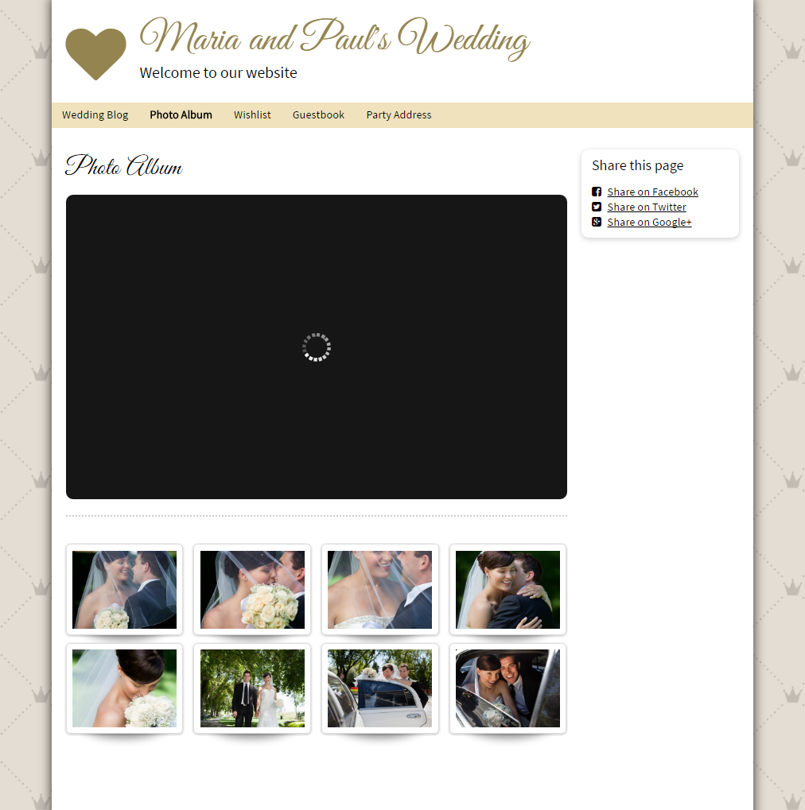

PIC 04 : Display all wishlist

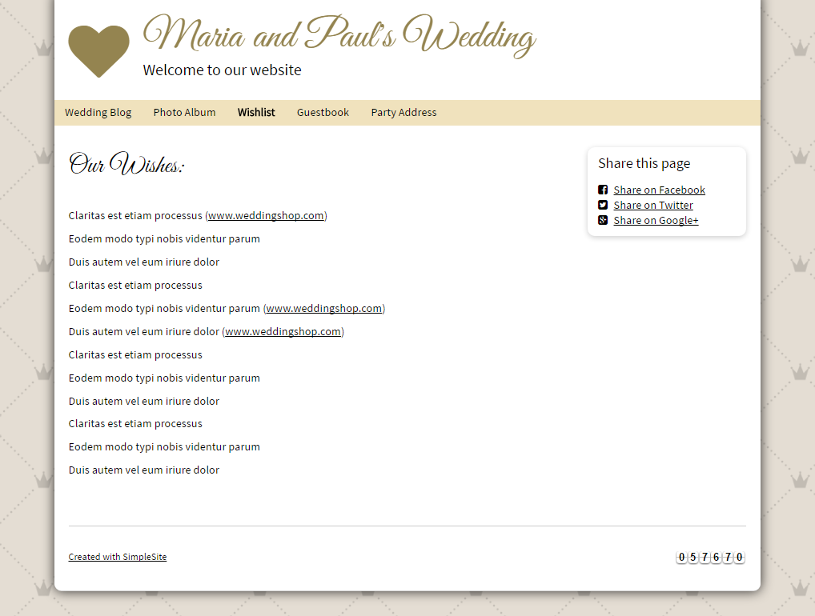

PIC 05 : Display guestbook

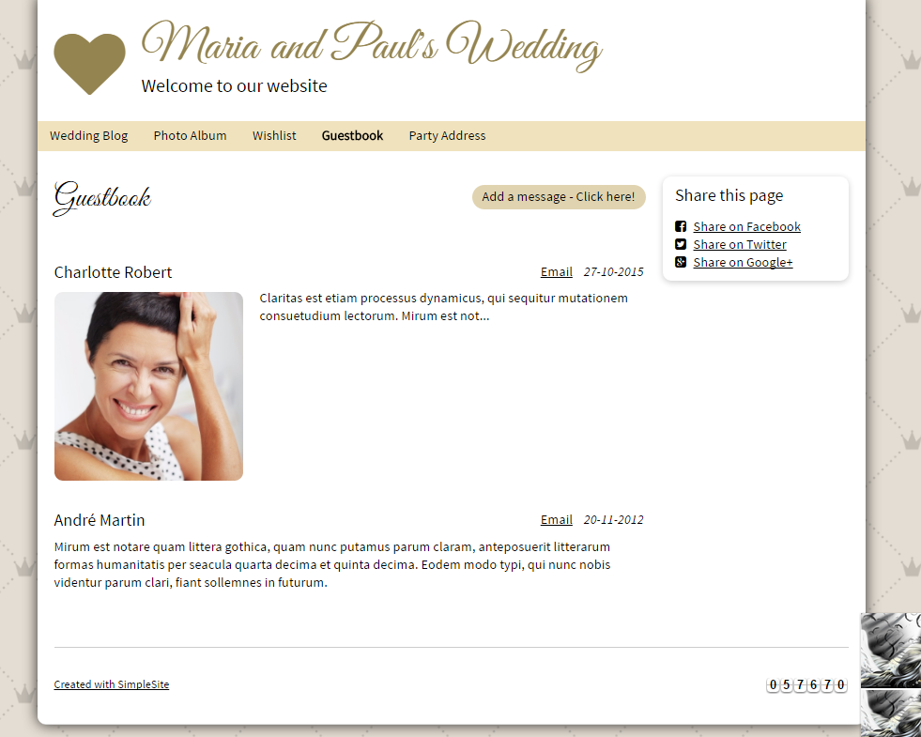

PIC 06 : Guest book – Add Message function

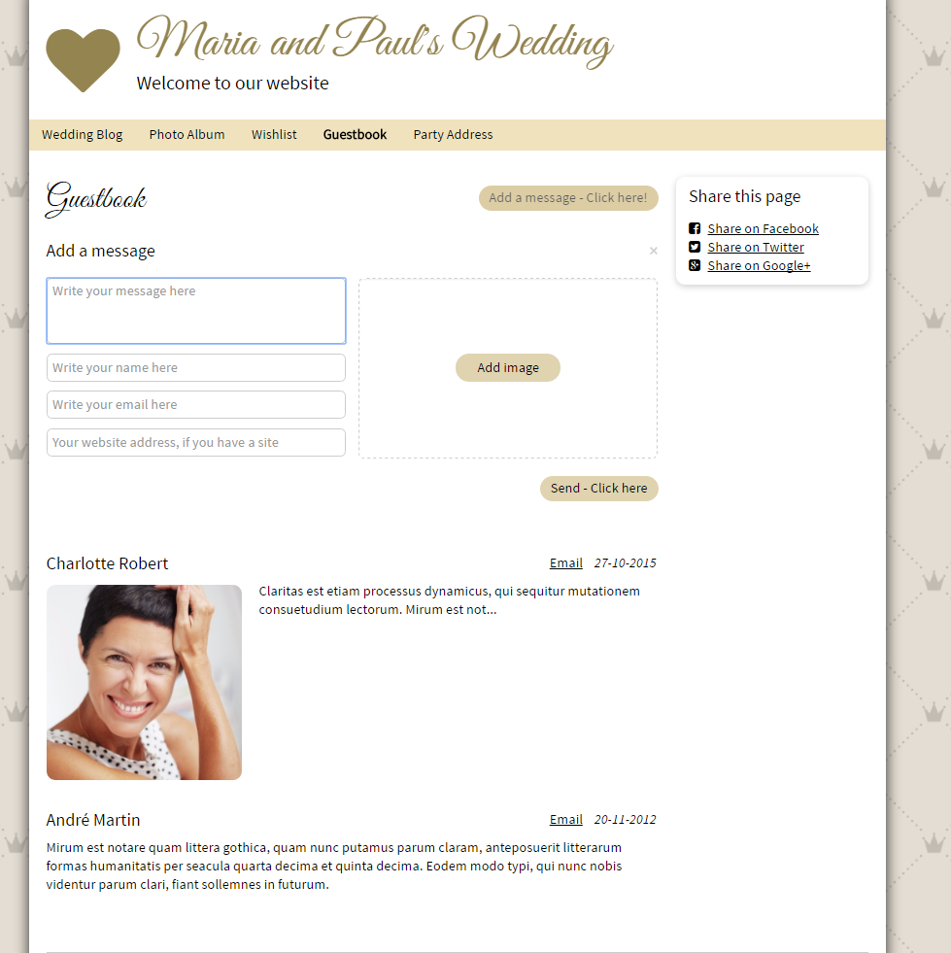

PIC 07 : Display party address

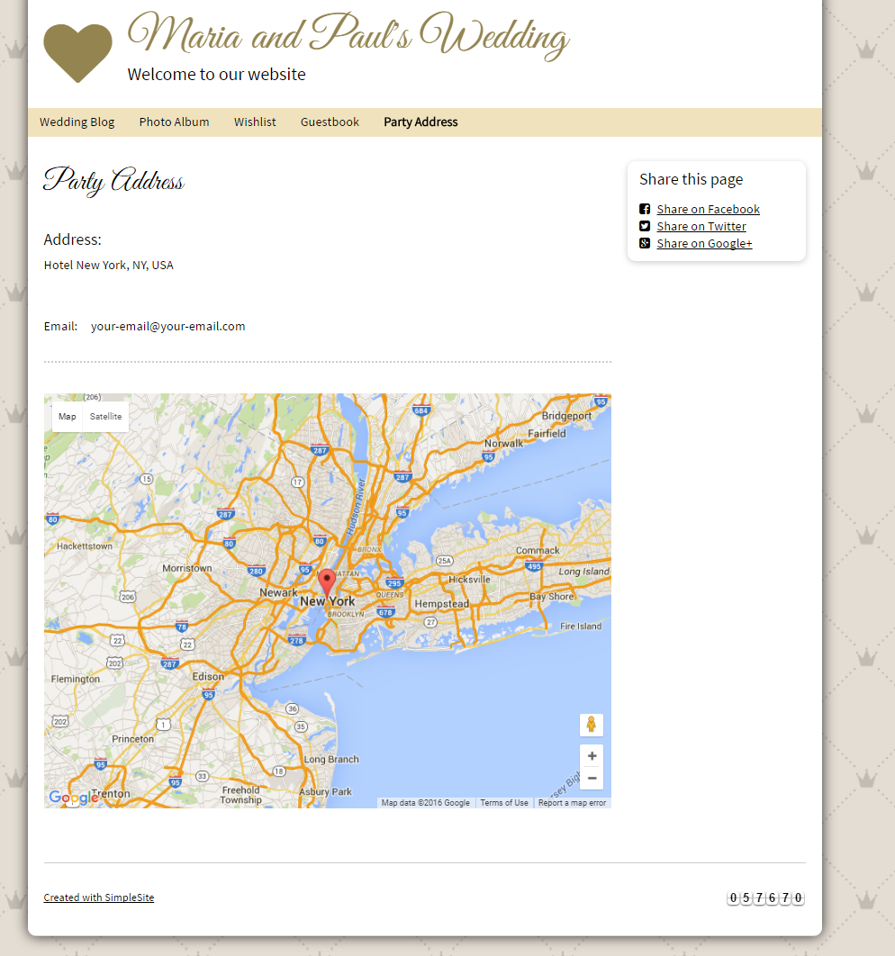

**Guidelines**

* Step 1 : Clarify requirement and scope with mentor
* Step 2 : Create prototype
* Step 3 : Design database base on created prototype
* Step 4 : Code & Test